MeFit User Manual

**Contents**

MeFit 2

Login page 2

Goals page 3

Dashboard page 3

Archived goal page 4

Exercise page 4

Workout page 4

Program page 4

Profile page 4

By

Veronica Andersen

Adrian Mattsson

Sona Rahimova

MeFit

MeFit is an application for managing and planning your workout. This application lets you choose exercises to add to your workouts for your programs and apply a goal for it. Purpose of this applications is to motivate and structure your workouts. It gives some premade programs and you can create your own.

Login page

Start application by typing *npm start*. This will take you to: <http://localhost:3000>. If you’re not logged in yet, you will be redirected to the login page. Otherwise you will be redirected to the start page.

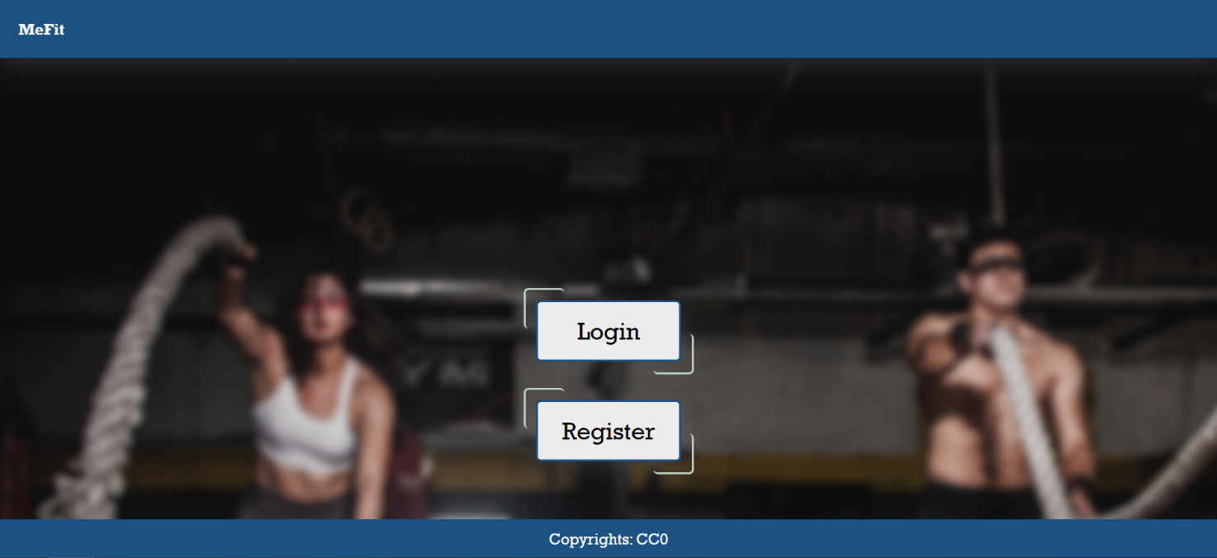

If it’s your first time visiting the website, you can register by clicking the register button. Here you will be asked to enter information about your: first name, last name, email, a username (which you can use to log in) and a password.

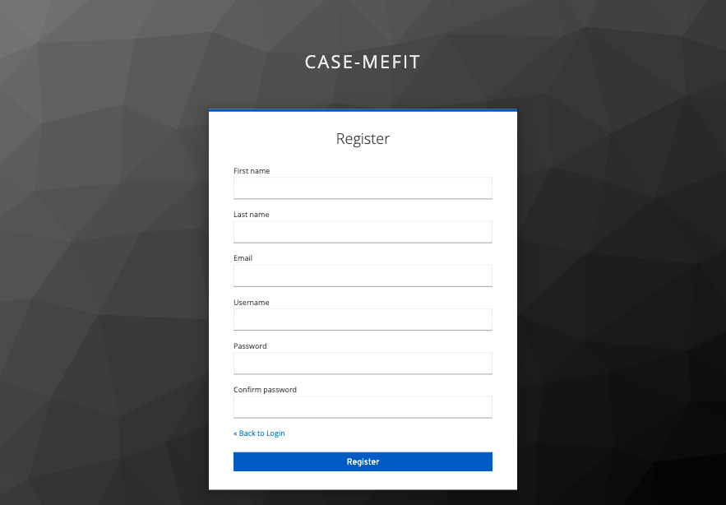

Because we have Mobile Authenticator Setup, it requires you to authenticate yourself when you log in. If it is first time you log in after you register it asks you to go to your mobile app Authenticator and enter the one-time code which is provided by the app. Adding a device name makes it easier to manage your OTP devices if you have more than one.

If you already have a registered a profile on the website, you can log in by entering your username/email and password. And enter the One-time code provided by Authenticator app on your mobile device.

Dashboard page

Dashboard will list all your goals in the calendar. You can navigate between days, weeks and month to see if you have any goals set up for a specific day/week/month.

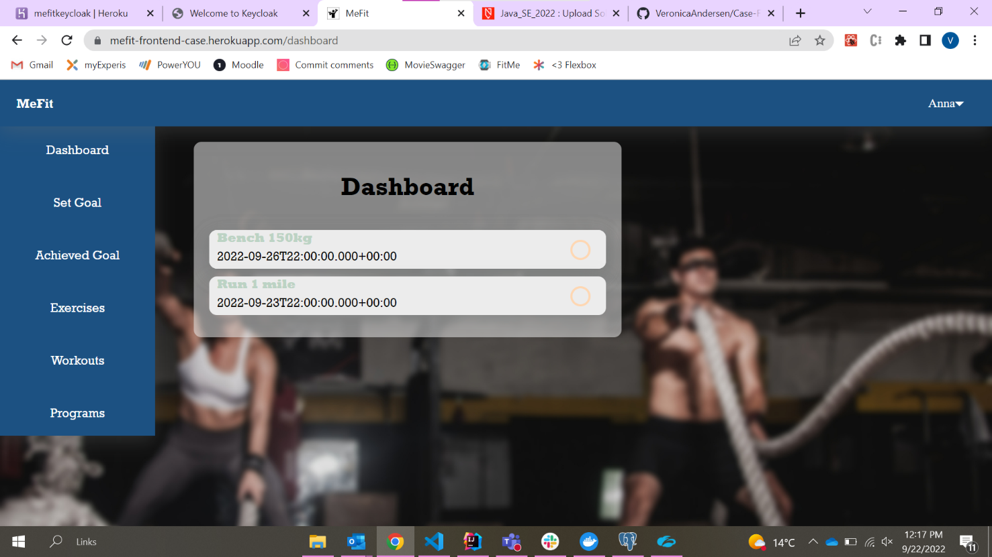

Set Goal page

Set goals page allows you to set your own goals and also list your goals that has been set.

Archived goal page

This page shows goals that has been achieved. This will help you to get more motivated and work towards your big goal.

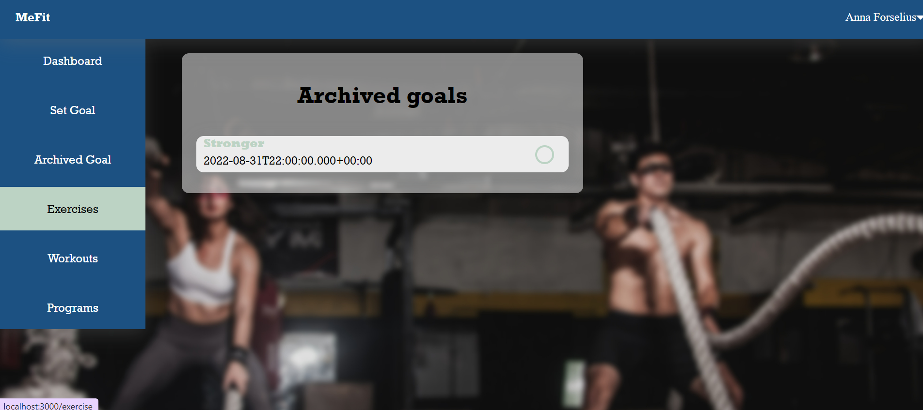

Exercise page

This page contains a list of all exercises, and it also allows you to create your own exercises. Here you can create a new set that you will need to add to a workout. These exercises that you create can later be added to your workout with a set connected to it. Each exercise can be edited if you want to customize it to your needs. So picture down below show the exercise page when its empty and next picture shows when exercises has been added.

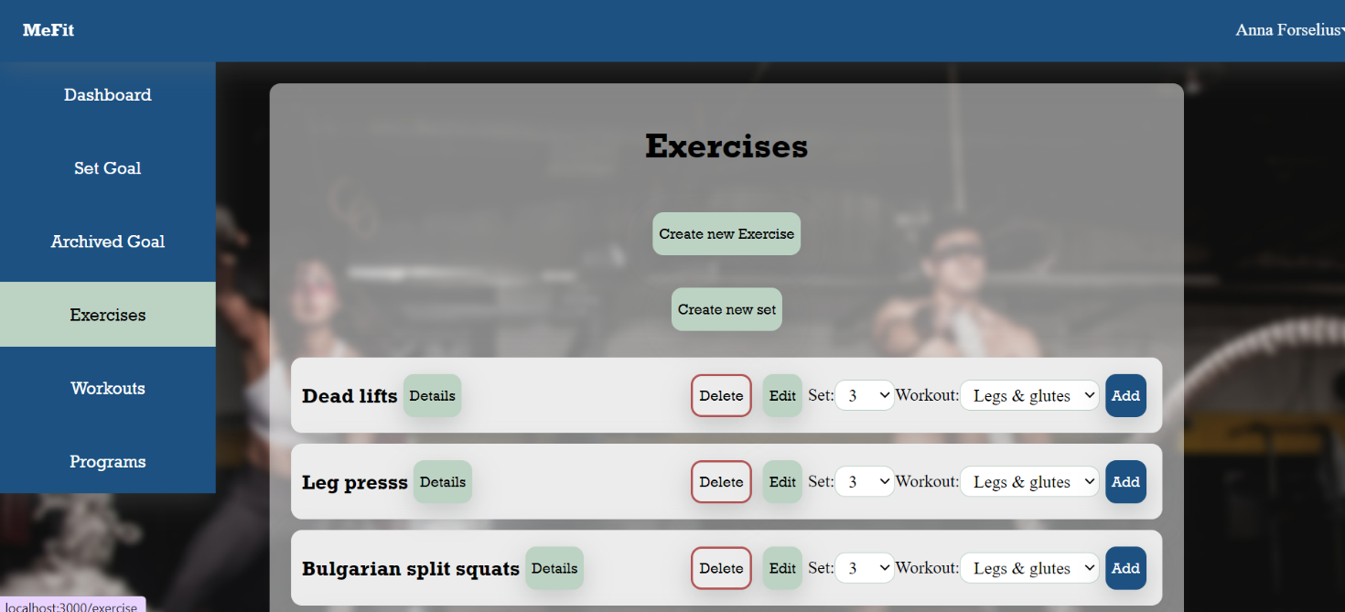

Workout page

Workout page contains a list of all workouts and allows you to create your own. These workouts can be added to a program. Just specify which program that you will add it to and click add. Each workout can easily be edited if you want to customize it to your needs.

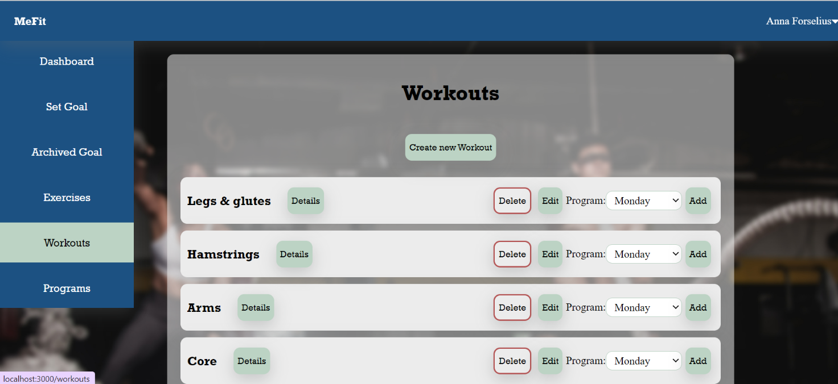

Program page

Program page contains a list of all programs and allows you to create your own. Each program can easily be edited if you want to customize it to your needs.

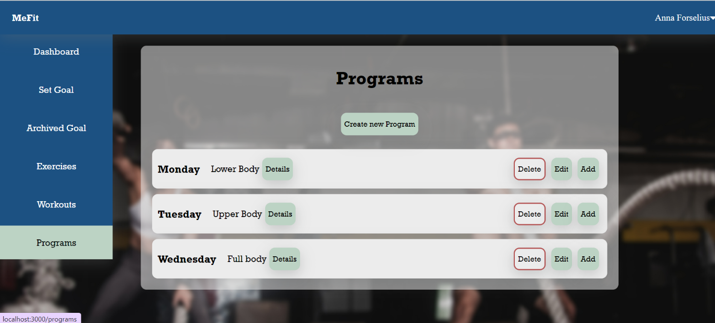

Profile page

Profile page contains your personal data. This data will help to check if the goals that has been set up are reasonable. You can edit this data by hovering over your name on the right corner of the page and going to Settings. The data that you can edit is your email, password, height and weight. You can also add 2FA to your account and request admin to be a contributor.

